ELC Meeting room, tablet LED controls over ADB.

ADB, controls over tablet led can be done in the simple method using the per-determined buttons like clicking the remote on a cheap LED Strip, more advanced methods allow you to set brightness values for your R , G, and B colors independently, this should allow for custom colors, brightness controls.

Make sure you have your tablet in adb root shell. Using adb root to restart the shell as root, if you want the tablet to boot up in adb root, pull the /system/build.prop file and add the following to the bottom of the file, push it back and reboot.
ro.secure=0
ro.debuggable=1

Simple LED Color Select
Using the simple color select method you need to turn on the led before changing color and turn off the led when you are done using it, when scripting this is not ideal but this is not an issues with advanced controls.

Control of the tablet led
adb shell “echo w 0x03 > ./sys/devices/platform/led_con_h/zigbee_reset”
this will turn on the led at last set color.
adb shell “echo w 0x04 > ./sys/devices/platform/led_con_h/zigbee_reset”
this will turn the led to red
adb shell “echo w 0x02 > ./sys/devices/platform/led_con_h/zigbee_reset”
this will turn off the led

picture reference, note the up and down brightness does not work using this method.
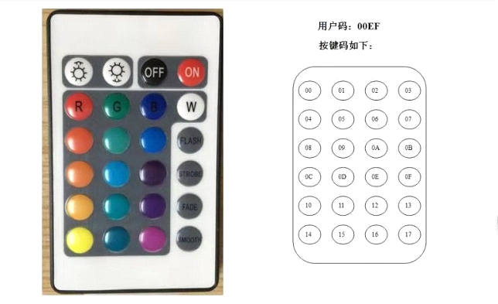

Advanced RGB Control:

We can also control the led using RGB values of 0-255 in hex using the tag below with the same command.
0X66RRGGBB
So to toggle the same red at full brightness you would use
adb shell “echo w 0x66FF0000 > ./sys/devices/platform/led_con_h/zigbee_reset”

To reduce it to 50% brightness
adb shell “echo w 0x667F0000 > ./sys/devices/platform/led_con_h/zigbee_reset”

The plus side to using this method is you do not need to toggle the lights on or off while controlling as you are setting the brightness value of each red, green and blue colors, below is a quick reference decimal to hexadecimal chart, this opens up a lot of possibilities for scripting.
Decimal-to-Hexadecimal Conversion Chart
Decimal | Hex | Decimal | Hex | Decimal | Hex | Decimal | Hex
0 | 0 | 64 | 40 | 128 | 80 | 192 | C0
1 | 1 | 65 | 41 | 129 | 81 | 193 | C1
2 | 2 | 66 | 42 | 130 | 82 | 194 | C2
3 | 3 | 67 | 43 | 131 | 83 | 195 | C3
4 | 4 | 68 | 44 | 132 | 84 | 196 | C4
5 | 5 | 69 | 45 | 133 | 85 | 197 | C5
6 | 6 | 70 | 46 | 134 | 86 | 198 | C6
7 | 7 | 71 | 47 | 135 | 87 | 199 | C7
8 | 8 | 72 | 48 | 136 | 88 | 200 | C8
9 | 9 | 73 | 49 | 137 | 89 | 201 | C9
10 | A | 74 | 4A | 138 | 8A | 202 | CA
11 | B | 75 | 4B | 139 | 8B | 203 | CB
12 | C | 76 | 4C | 140 | 8C | 204 | CC
13 | D | 77 | 4D | 141 | 8D | 205 | CD
14 | E | 78 | 4E | 142 | 8E | 206 | CE
15 | F | 79 | 4F | 143 | 8F | 207 | CF
16 | 10 | 80 | 50 | 144 | 90 | 208 | D0
17 | 11 | 81 | 51 | 145 | 91 | 209 | D1
18 | 12 | 82 | 52 | 146 | 92 | 210 | D2
19 | 13 | 83 | 53 | 147 | 93 | 211 | D3
20 | 14 | 84 | 54 | 148 | 94 | 212 | D4
21 | 15 | 85 | 55 | 149 | 95 | 213 | D5
22 | 16 | 86 | 56 | 150 | 96 | 214 | D6
23 | 17 | 87 | 57 | 151 | 97 | 215 | D7
24 | 18 | 88 | 58 | 152 | 98 | 216 | D8
25 | 19 | 89 | 59 | 153 | 99 | 217 | D9
26 | 1A | 90 | 5A | 154 | 9A | 218 | DA
27 | 1B | 91 | 5B | 155 | 9B | 219 | DB
28 | 1C | 92 | 5C | 156 | 9C | 220 | DC
29 | 1D | 93 | 5D | 157 | 9D | 221 | DD
30 | 1E | 94 | 5E | 158 | 9E | 222 | DE
31 | 1F | 95 | 5F | 159 | 9F | 223 | DF
32 | 20 | 96 | 60 | 160 | A0 | 224 | E0
33 | 21 | 97 | 61 | 161 | A1 | 225 | E1
34 | 22 | 98 | 62 | 162 | A2 | 226 | E2
35 | 23 | 99 | 63 | 163 | A3 | 227 | E3
36 | 24 | 100 | 64 | 164 | A4 | 228 | E4
37 | 25 | 101 | 65 | 165 | A5 | 229 | E5
38 | 26 | 102 | 66 | 166 | A6 | 230 | E6
39 | 27 | 103 | 67 | 167 | A7 | 231 | E7
40 | 28 | 104 | 68 | 168 | A8 | 232 | E8
41 | 29 | 105 | 69 | 169 | A9 | 233 | E9
42 | 2A | 106 | 6A | 170 | AA | 234 | EA
43 | 2B | 107 | 6B | 171 | AB | 235 | EB
44 | 2C | 108 | 6C | 172 | AC | 236 | EC
45 | 2D | 109 | 6D | 173 | AD | 237 | ED
46 | 2E | 110 | 6E | 174 | AE | 238 | EE
47 | 2F | 111 | 6F | 175 | AF | 239 | EF
48 | 30 | 112 | 70 | 176 | B0 | 240 | F0
49 | 31 | 113 | 71 | 177 | B1 | 241 | F1
50 | 32 | 114 | 72 | 178 | B2 | 242 | F2
51 | 33 | 115 | 73 | 179 | B3 | 243 | F3
52 | 34 | 116 | 74 | 180 | B4 | 244 | F4
53 | 35 | 117 | 75 | 181 | B5 | 245 | F5
54 | 36 | 118 | 76 | 182 | B6 | 246 | F6
55 | 37 | 119 | 77 | 183 | B7 | 247 | F7
56 | 38 | 120 | 78 | 184 | B8 | 248 | F8
57 | 39 | 121 | 79 | 185 | B9 | 249 | F9
58 | 3A | 122 | 7A | 186 | BA | 250 | FA
59 | 3B | 123 | 7B | 187 | BB | 251 | FB
60 | 3C | 124 | 7C | 188 | BC | 252 | FC
61 | 3D | 125 | 7D | 189 | BD | 253 | FD
62 | 3E | 126 | 7E | 190 | BE | 254 | FE
63 | 3F | 127 | 7F | 191 | BF | 255 | FF

Tested on a WA8058T purchased though aliexpress

